Station 1

Document A
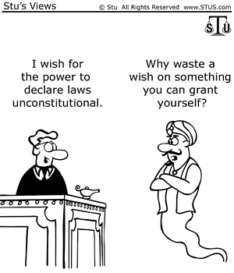

Documents A. Questions
- Who is the person on the left supposed to represent?
- What Supreme Court case could this represent?
- What is the term for declaring laws unconstitutional?
- Create a title for this cartoon.

Document B
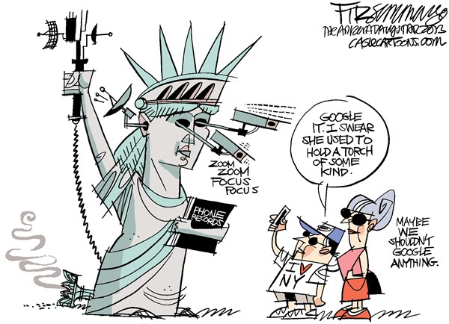

Document B. Questions
- Explain what the Statue of Liberty is doing to the people.
- Why did the woman say, “Maybe We Shouldn’t Google Anything?”
- What Act by Congress is this document talking about?
- Create a title for this cartoon.

Station 2

Document C

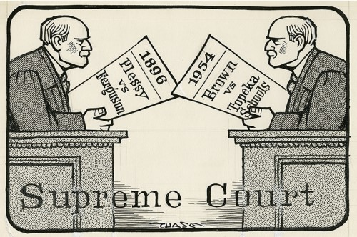

Document C Questions:
- What subject do these two cases have in common?
- Explain the decision of Plessey v. Ferguson.
- Explain the decision of Brown v. Board of Education.
- Create a title for this document.

Document D
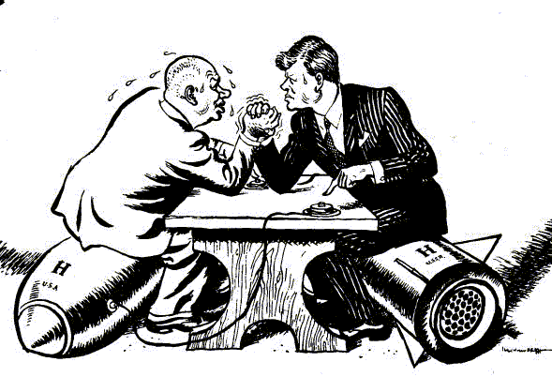

Document D Questions:
- What are the men sitting on?
- Why are the men in the document arm wrestling?
- Which two forms of governments are represented from these leaders?
- Create a title for this document.

Station 3

Document E

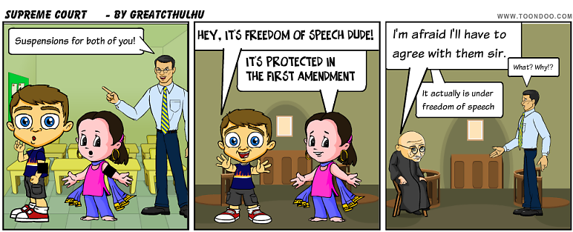

Document E Questions:
- Which Supreme Court case is this cartoon best representing?
- Describe the details of that case.
- How has the ruling in this case been modified by later Supreme Court decisions?
- Create a title for this cartoon.

Document F
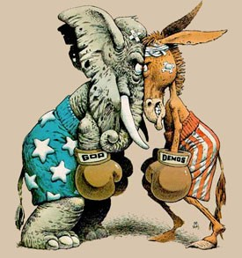

Document F Questions:
- What groups are these animals representing?
- How do these two groups feel about one another? How do you know this?
- Explain two facts about each of the groups represented in this carton.
- Create a title for this cartoon.

Station 4
Document G
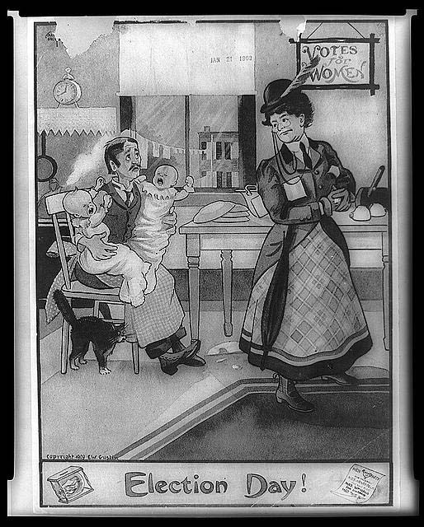

Document G Questions:
- What is the term for the rights she wants?
- Which amendment granted her these rights?
- What two other amendments granted similar rights?

Document H
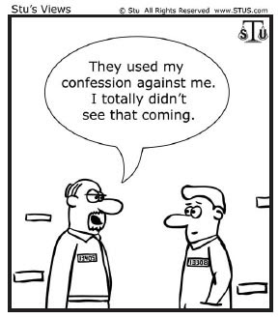

Document H Questions:
- Which Supreme Court case prevents this from happening?
- Which amendment allows people to prevent this?
- What other Supreme Court case protects the rights of the accused?
- Which other amendments protect the rights of the accused?

Station 5
Document I
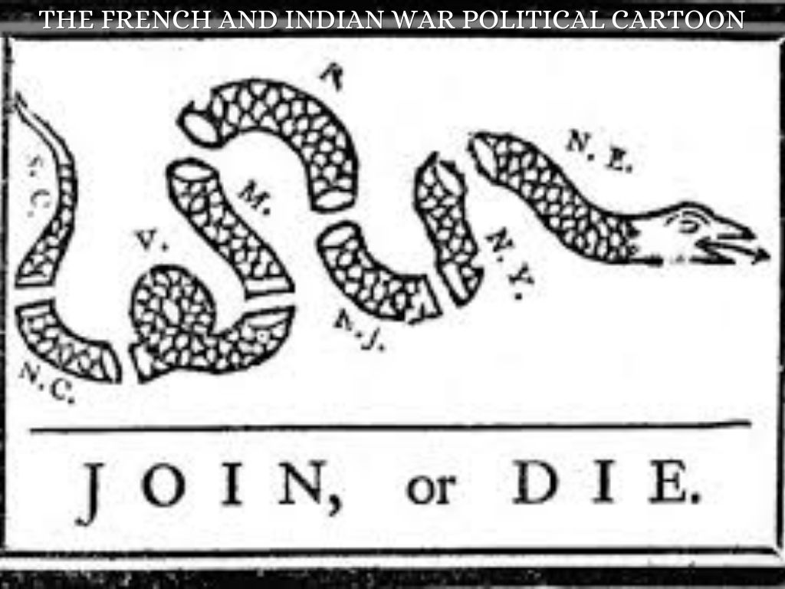

Document I Questions:
- What is the author of this cartoon trying to say?
- How did this war lead to tensions between England and the colonies?
- Describe three grievances that ultimately the colonists had with England.

Document J
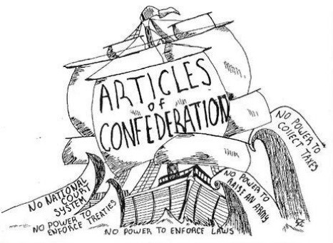

Document J Questions:
- Would a Federalist or Anti-Federalist more likely author this cartoon?
- What does the ship represent? What does the water represent?
- What wave eventually led to the “sinking of the ship”?

